**Simple Quiz Application Using Java**

Submitted in partial of the requirements for the degree of Bachelor of Science in

Information Technology (ITE 186: Computer Programming II)

Members:

Mesa, Daniel Karl

April 10, 2025

**Objective**

This program operates on OOP and GUI principles of Java and will be designed to allow users to answer questions in a quiz-type format against which users will be scored at the end of each quiz, providing an easy and engaging means of testing.

**Introduction**

Simple Quiz application is India-specific software, developed in a desktop environment. It is made up of pure Java code and uses Swing for the GUI. It is the most simplistic quiz that enables use of answering a identification question, with an automatic checking of the final score. To program it, basic concepts of programming include conditionals, loops, and some OOP principles. The interface is through JOptionPane, making it easily usable.

**Modules**

1.Welcome Module:

* + Displays a welcome message and introduces the quiz to the user.

1. User Interaction:
   * Asks for the user’s name and customizes the quiz experience by greeting the user by name.
2. Quiz Questions:
   * Users are presented with a series of 5 questions about the Philippines.
   * Each question is followed by a text input for the user to answer.
   * The system evaluates the answer and increases the score if correct.
3. Score Evaluation:
   * At the end of the quiz, the user’s total score is displayed.
   * The score is based on how many answers were correct out of 5.
4. Exit Message:
   * After completing the quiz, the user is thanked for participating.

**Analysis**

**A.Process Logic**

**Stage 1**: The application is opened by the user and then greeted by welcome messages.

**Stage 2**: The user types in his name to personalize the experience.

**Stage 3**: The user answers five questions pertaining to the Philippines.

**Stage 4**: The system checks the answers and adds points to the score for each correct answer.

**Stage 5**: The final score is displayed, along with a reply thanking the user for participating.

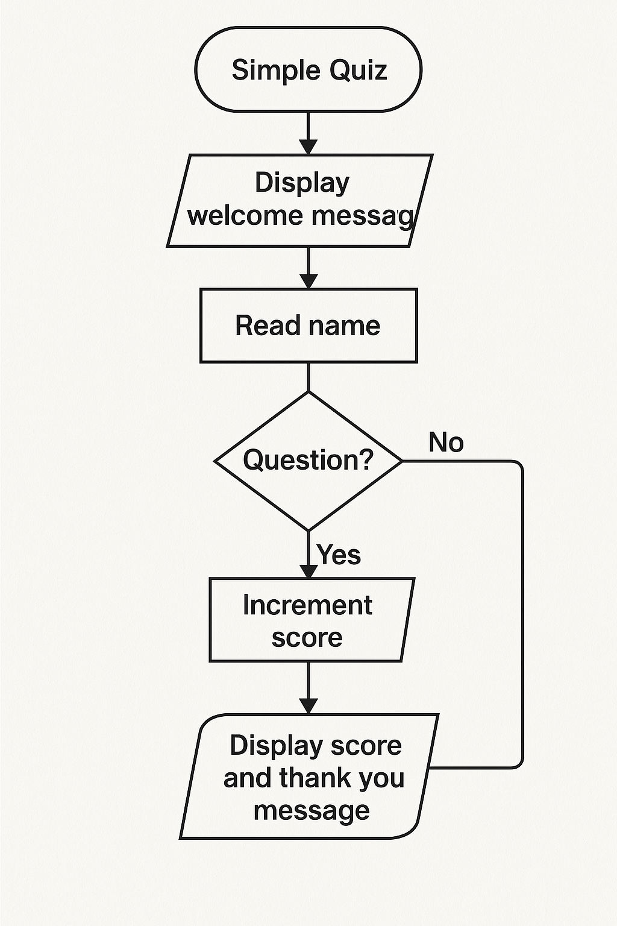 **B. Data Flow Using Flowchart Diagram**

**Tools and Platforms Used:**

1. **Java** – The primary programming language used to develop the quiz application.
2. **Swing (JOptionPane)** – For creating dialog-based graphical user interfaces.
3. **Microsoft Visual Studio Code (VS Code)** – The code editor used for writing, editing, and managing the Java project.
4. **JDK (Java Development Kit)** – Used to compile and run Java programs.
5. **Command Prompt / Terminal** – For compiling and executing the Java program when not using an IDE.

**Algorithm, Flowchart, and Program**

**Algorithm: To run the Simple Quiz Application**

1. Start
2. Display welcome message
3. Ask for the user’s name
4. Ask 5 quiz questions
5. For each question:  
   a. Get the user's answer  
   b. Check if the answer is correct  
   c. Increment score if correct
6. Display the final score
7. Thank the user
8. Stop

**Flowchart**

**Program**

import javax.swing.JOptionPane;

public class SimpleQuiz {

public static void main(String[] args) {

int score = 0;

// Step 1: Welcome message

JOptionPane.showMessageDialog(null, "Welcome to the Simple Quiz!");

JOptionPane.showMessageDialog(null, "This quiz will test your knowledge about the Philippines.");

// Step 2: Get user name

String name = JOptionPane.showInputDialog("Enter your name:");

JOptionPane.showMessageDialog(null, "Welcome " + name + "! Let's start the quiz.");

// Step 3: Ask questions and evaluate answers

String answer1 = JOptionPane.showInputDialog("Question 1: Who is the first president of the Philippines?");

if (answer1.equalsIgnoreCase("Emilio Aguinaldo")) {

score++;

}

String answer2 = JOptionPane.showInputDialog("Question 2: What is the capital of the Philippines?");

if (answer2.equalsIgnoreCase("Manila")) {

score++;

}

String answer3 = JOptionPane.showInputDialog("Question 3: Who is the painter of Spolarium?");

if (answer3.equalsIgnoreCase("Juan Luna")) {

score++;

}

String answer4 = JOptionPane.showInputDialog("Question 4: What is the national flower of the Philippines?");

if (answer4.equalsIgnoreCase("Sampaguita")) {

score++;

}

String answer5 = JOptionPane.showInputDialog("Question 5: What is the national animal of the Philippines?");

if (answer5.equalsIgnoreCase("Carabao")) {

score++;

}

// Step 4: Display final result

JOptionPane.showMessageDialog(null, "Thank you for taking the quiz, " + name + "!");

JOptionPane.showMessageDialog(null, "You answered " + score + " out of 5 questions correctly.");

}

}